# Intro to Computing LABORATORY

Midterm Activity 4

Name:

**Objectives:**

Create webpage that uses a box model

Reference: <https://www.w3schools.com/css/css_boxmodel.asp>

**Directions:**

1. Open the HTML file named OROZCOMidAct4.html to view the web page that has no design. Rename with your last name. Open this in Notepad and Modify the Last Name in the H2 tag. Modify also the name of the CSS file inside the link tag.
2. Create a .css file (external CSS) named LastNameStyle4.css. Type and modify the following codes in Notepad (or any editor). Please follow the file name format.

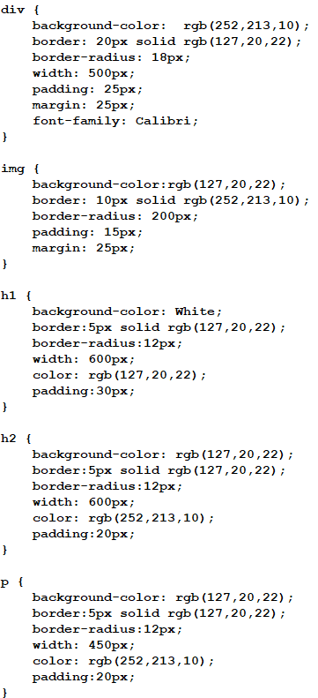

1. Modify the design of your webpage to make it personalized and unique.
2. Open the saved html file and screenshot.

Sample Screenshot in the Web Browser:

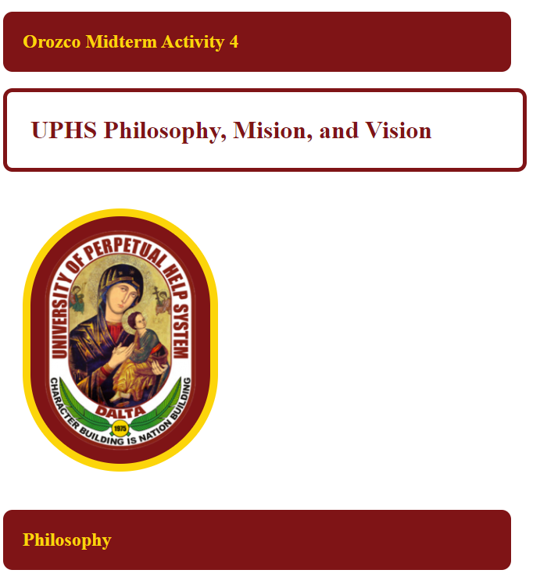





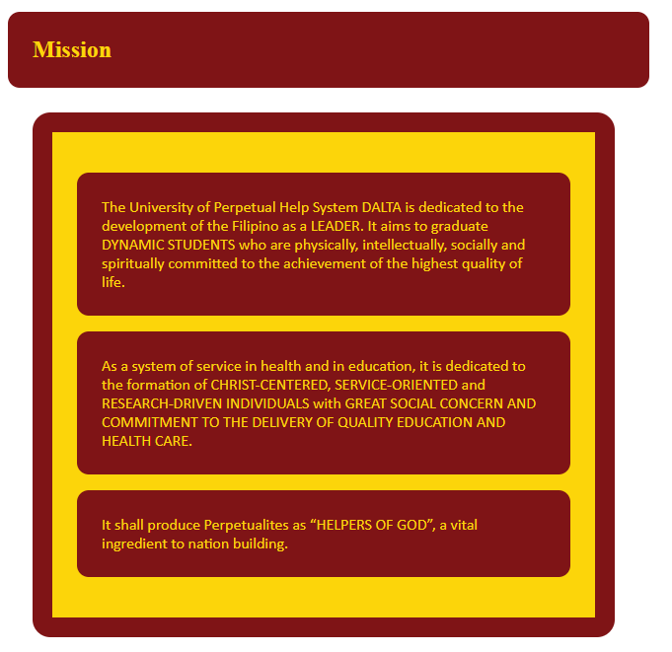

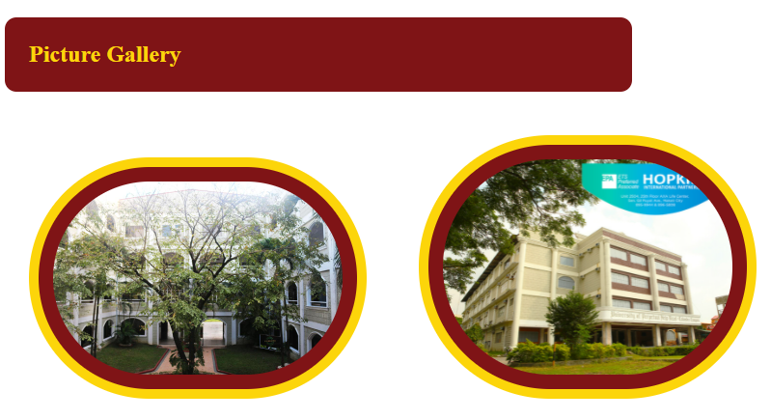

1. Upload the html and css files and picture in the LMS.